1. <https://web.facebook.com/profile.php?id=61551028808517>

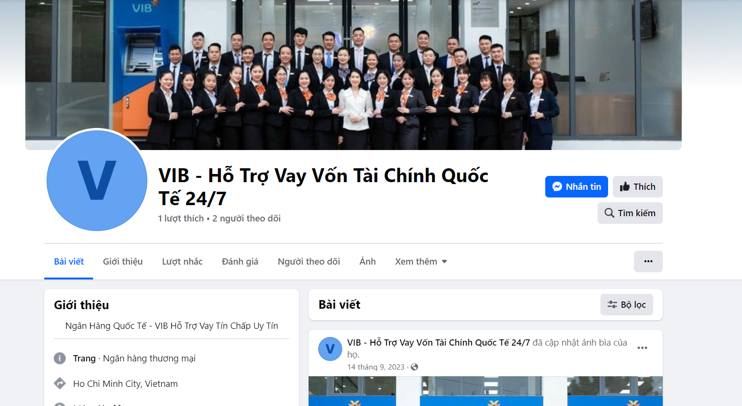

1. <https://web.facebook.com/profile.php?id=100090890420733>

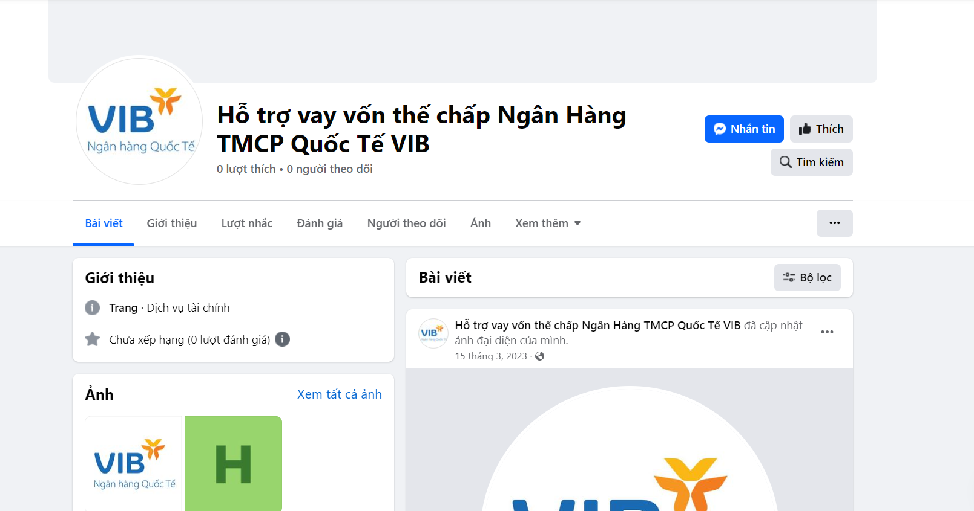

1. <https://web.facebook.com/profile.php?id=100089801505176>

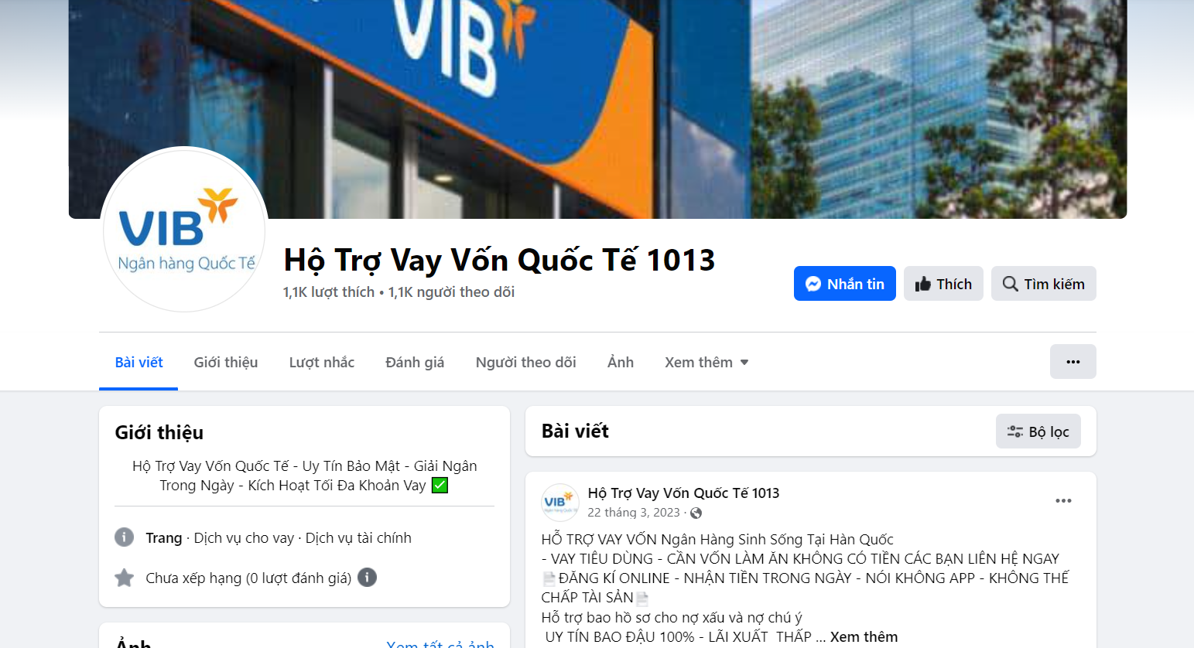

1. <https://web.facebook.com/profile.php?id=61555269280885>

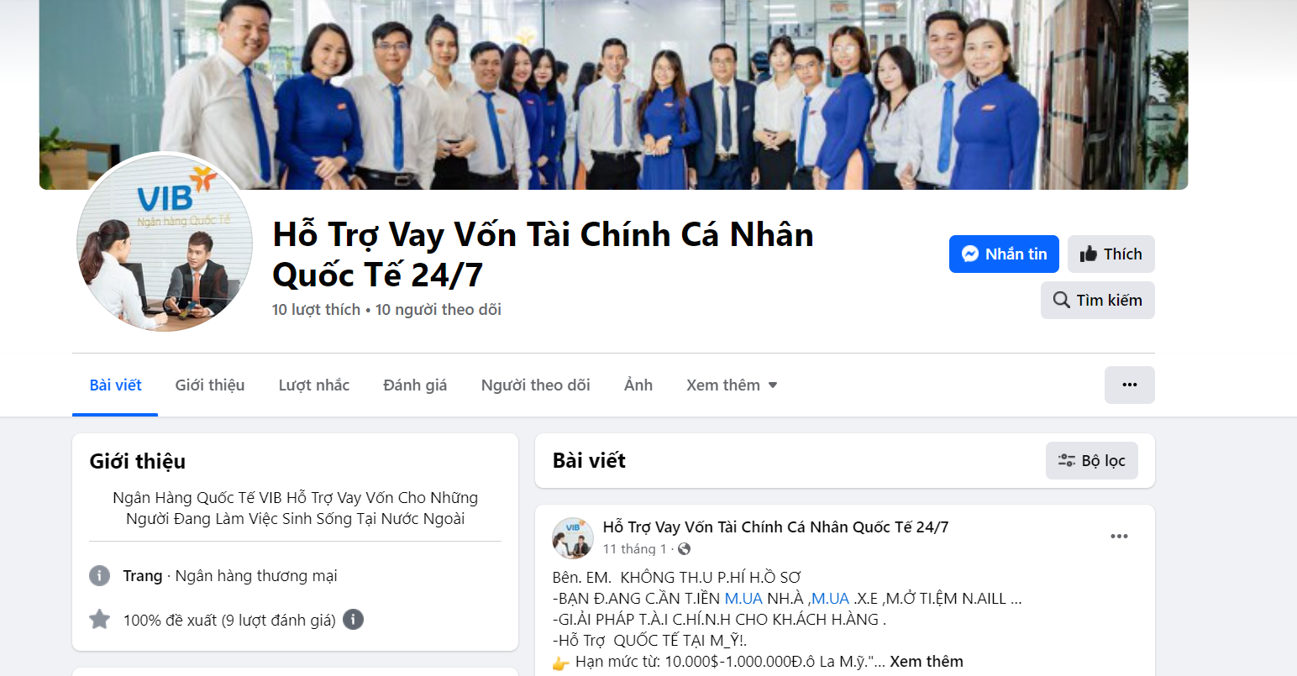

1. <https://web.facebook.com/profile.php?id=61555578032587>

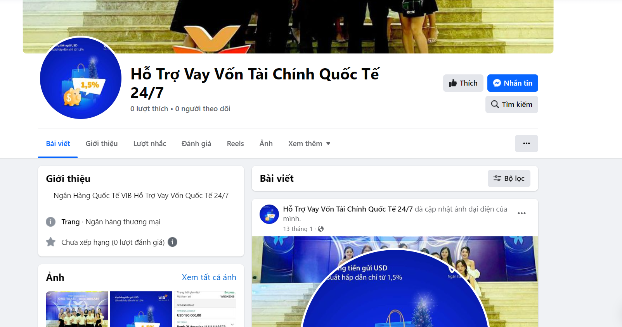

1. <https://web.facebook.com/profile.php?id=61551794331697>

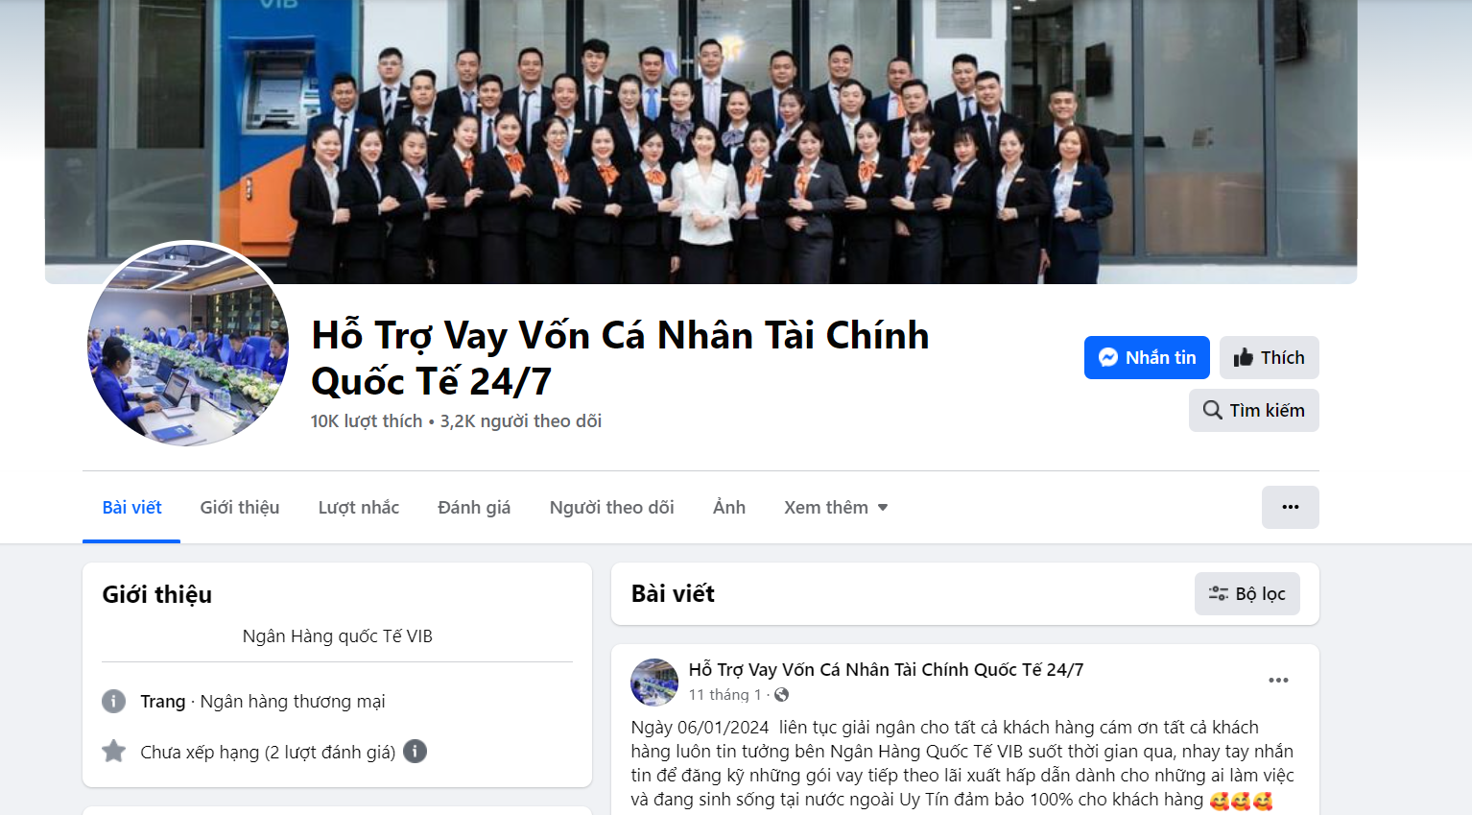

1. <https://web.facebook.com/profile.php?id=100094435707743>

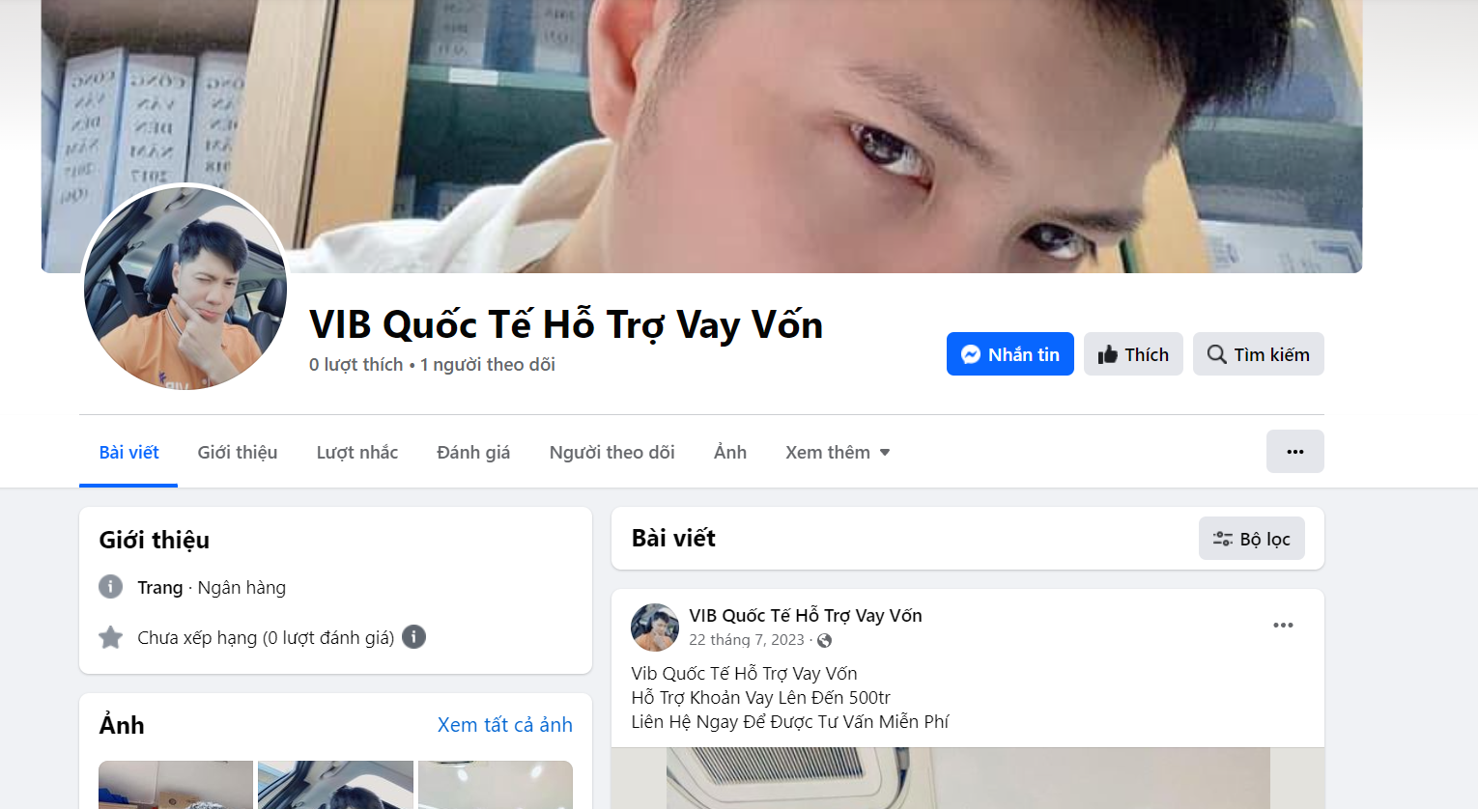

1. <https://web.facebook.com/ngocthienha.land>

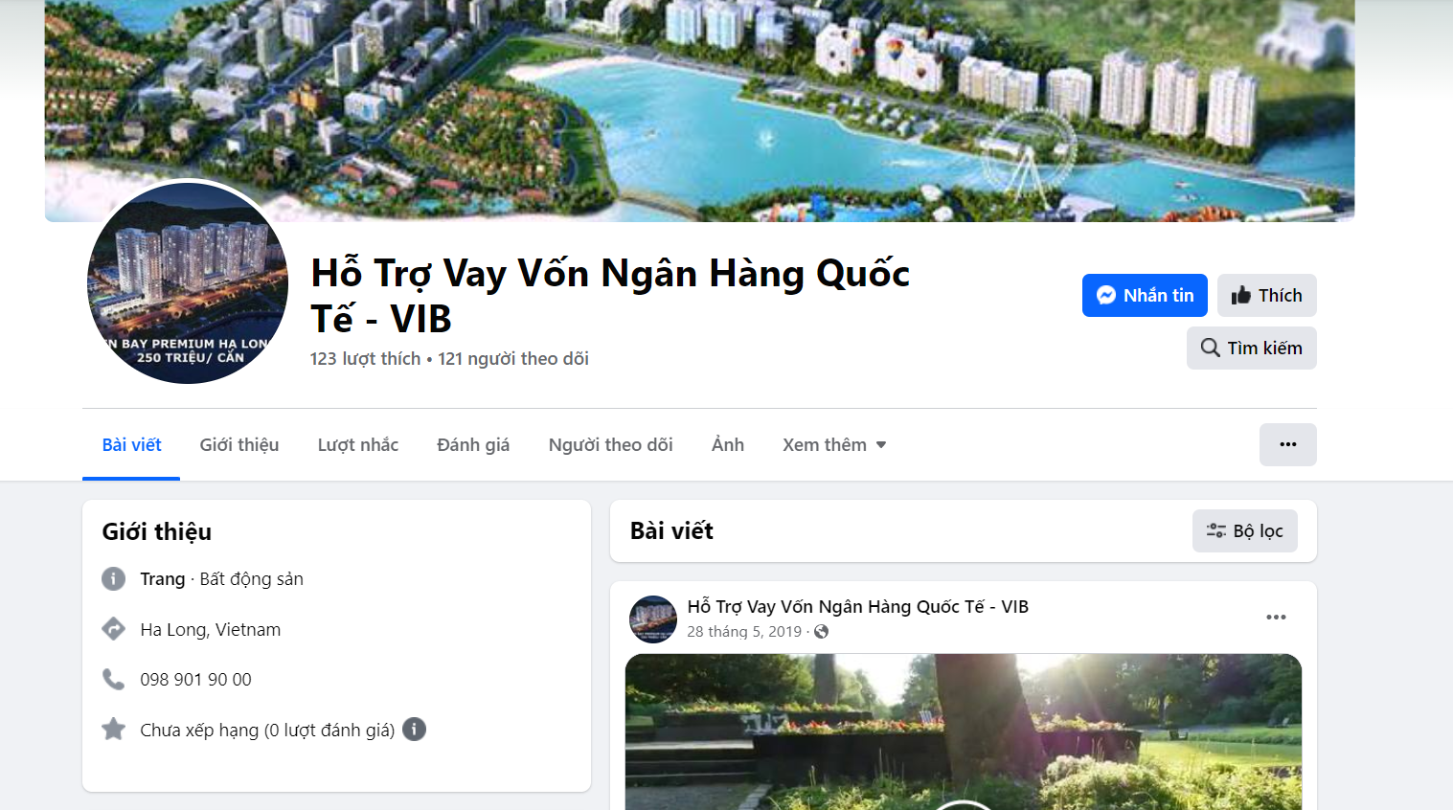

1. <https://web.facebook.com/profile.php?id=100091053671048>

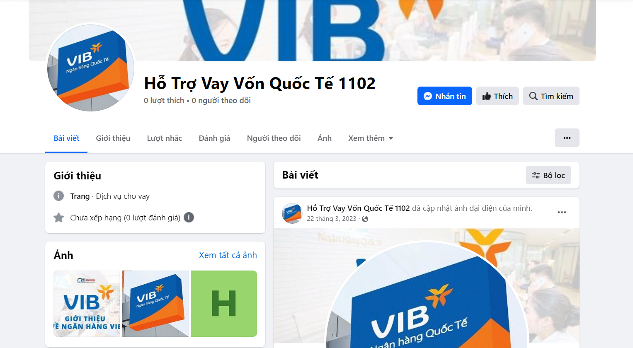

1. <https://web.facebook.com/HotrovayTP>

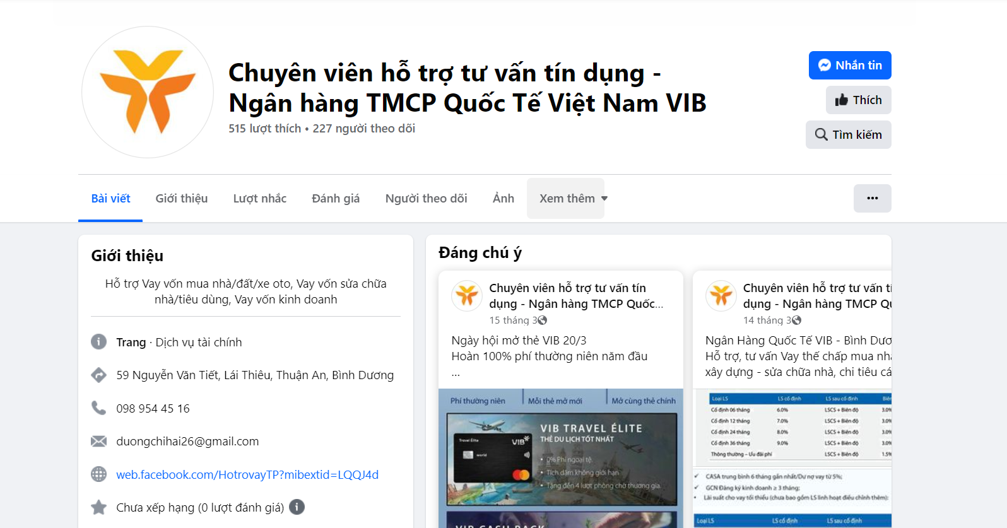

1. <https://web.facebook.com/profile.php?id=61554478423426>

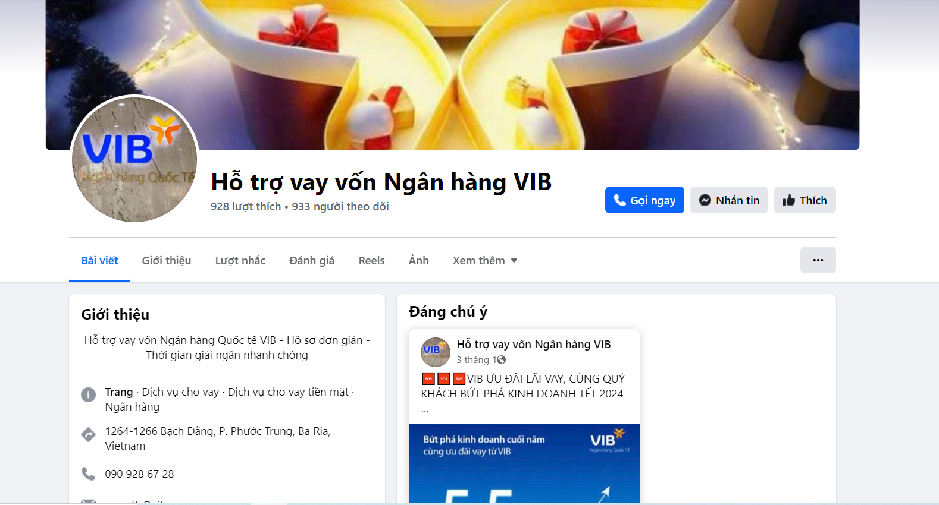

1. <https://web.facebook.com/MrPhucVib>

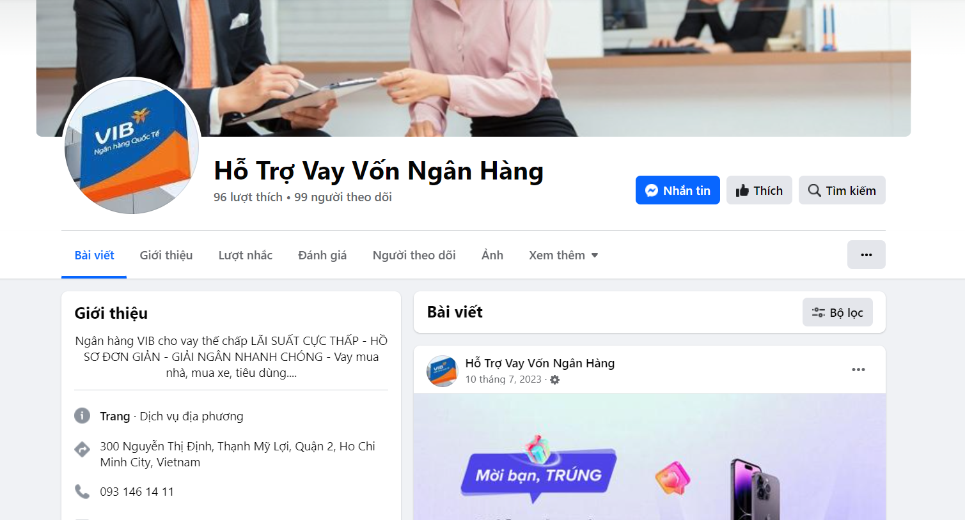

1. <https://web.facebook.com/profile.php?id=100082490203010>

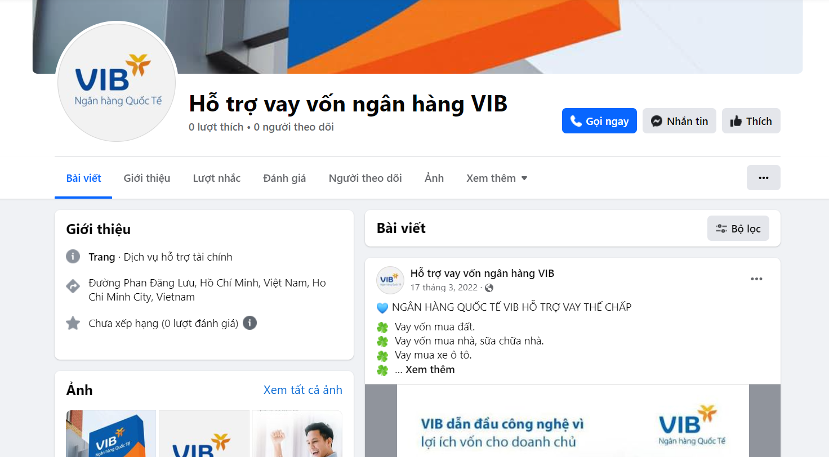

1. <https://web.facebook.com/profile.php?id=100083303843240>

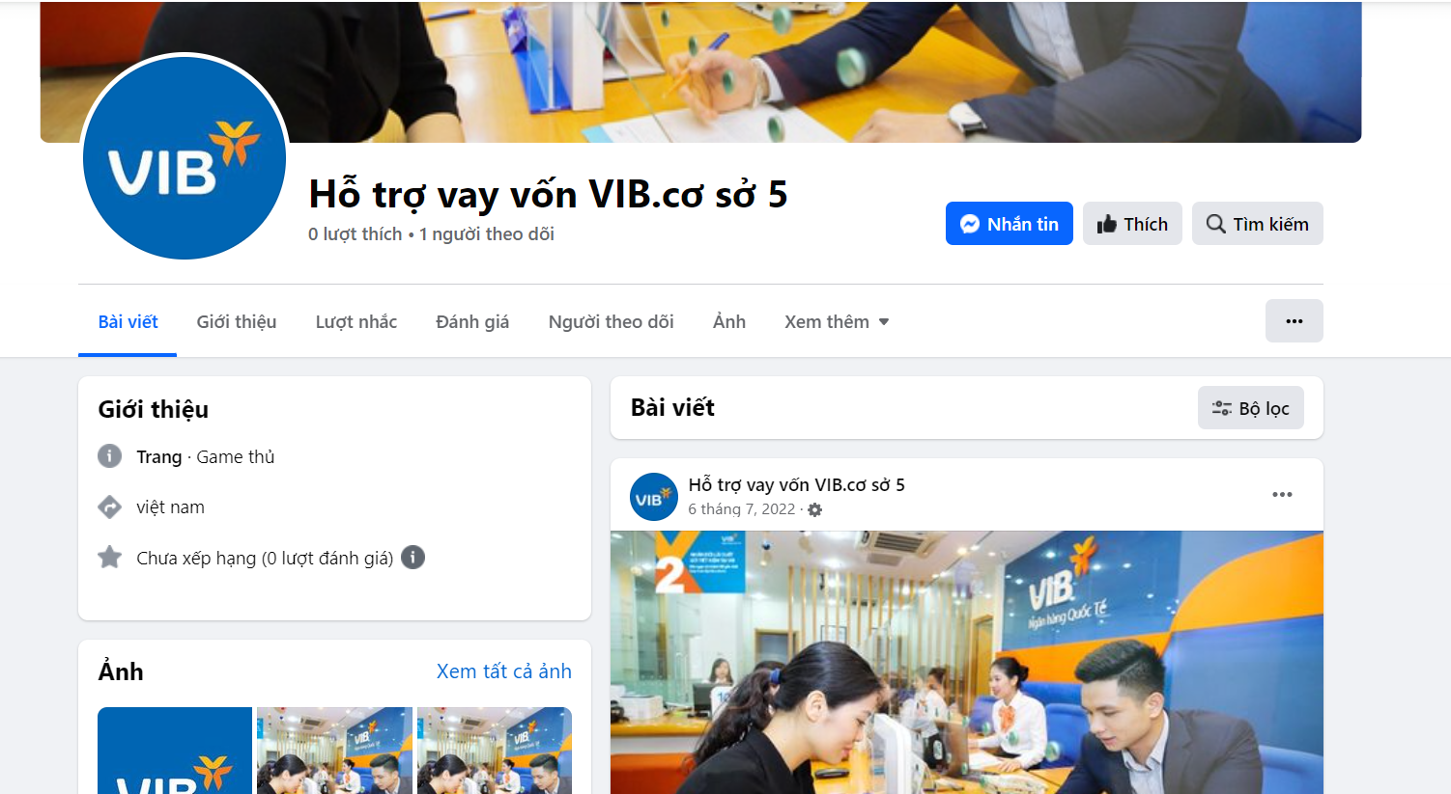

1. <https://web.facebook.com/profile.php?id=100076863544814>

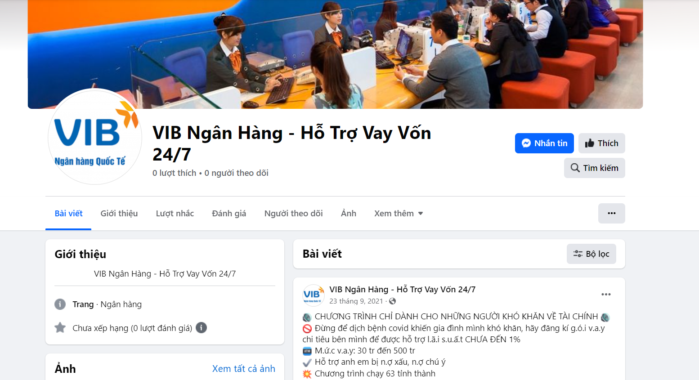

1. <https://web.facebook.com/profile.php?id=100081957271379>

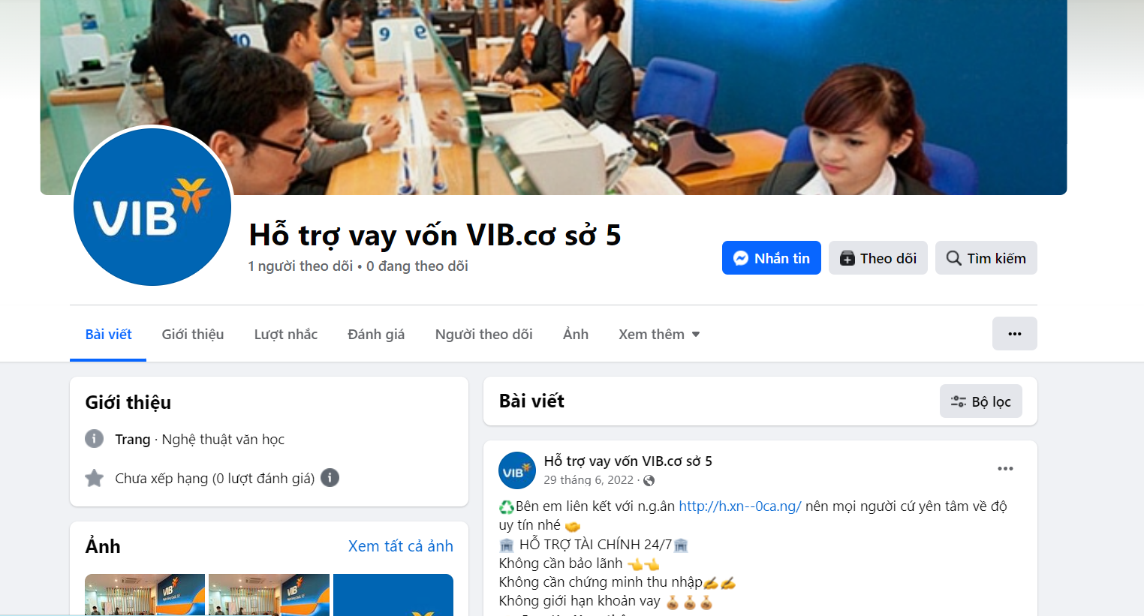

1. <https://web.facebook.com/profile.php?id=100087998210025>

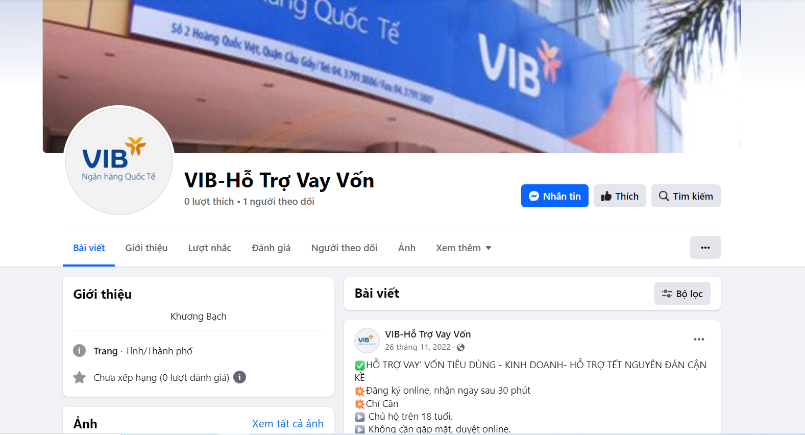

1. <https://web.facebook.com/profile.php?id=100081959520700>

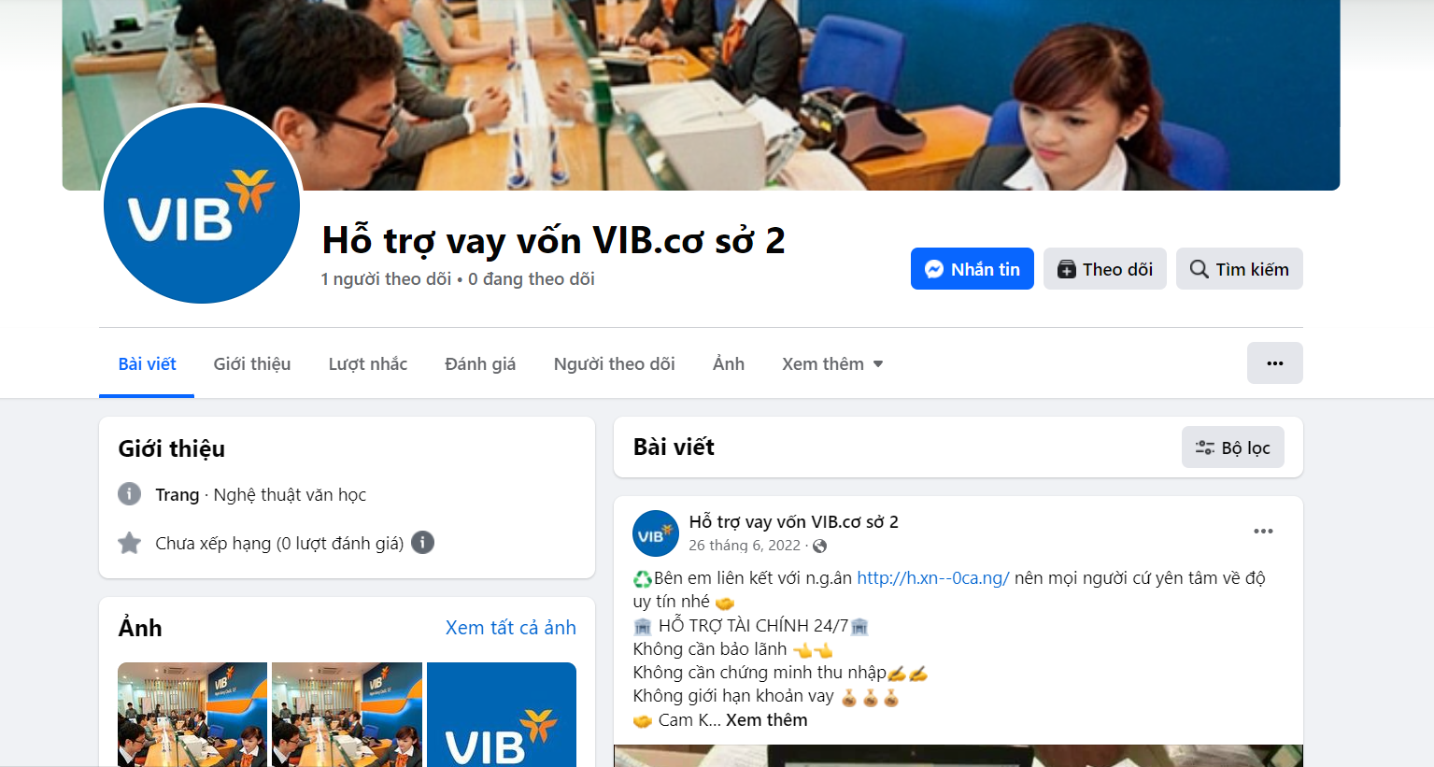

1. <https://web.facebook.com/profile.php?id=100083492135392>

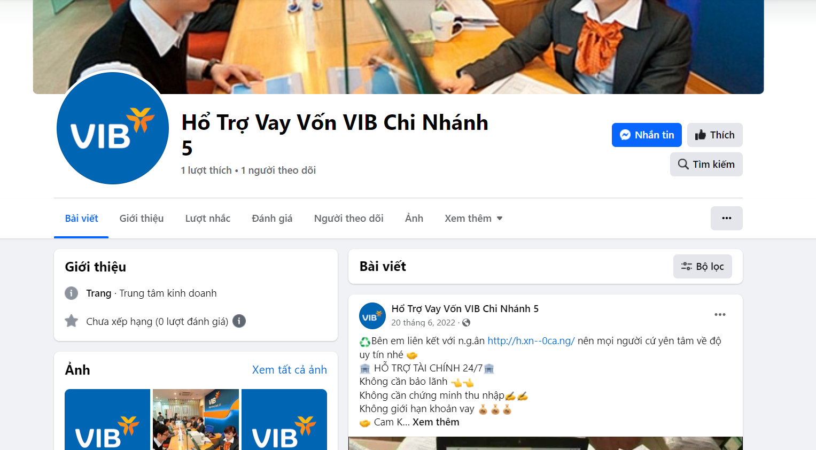

1. <https://web.facebook.com/profile.php?id=100086648307948>

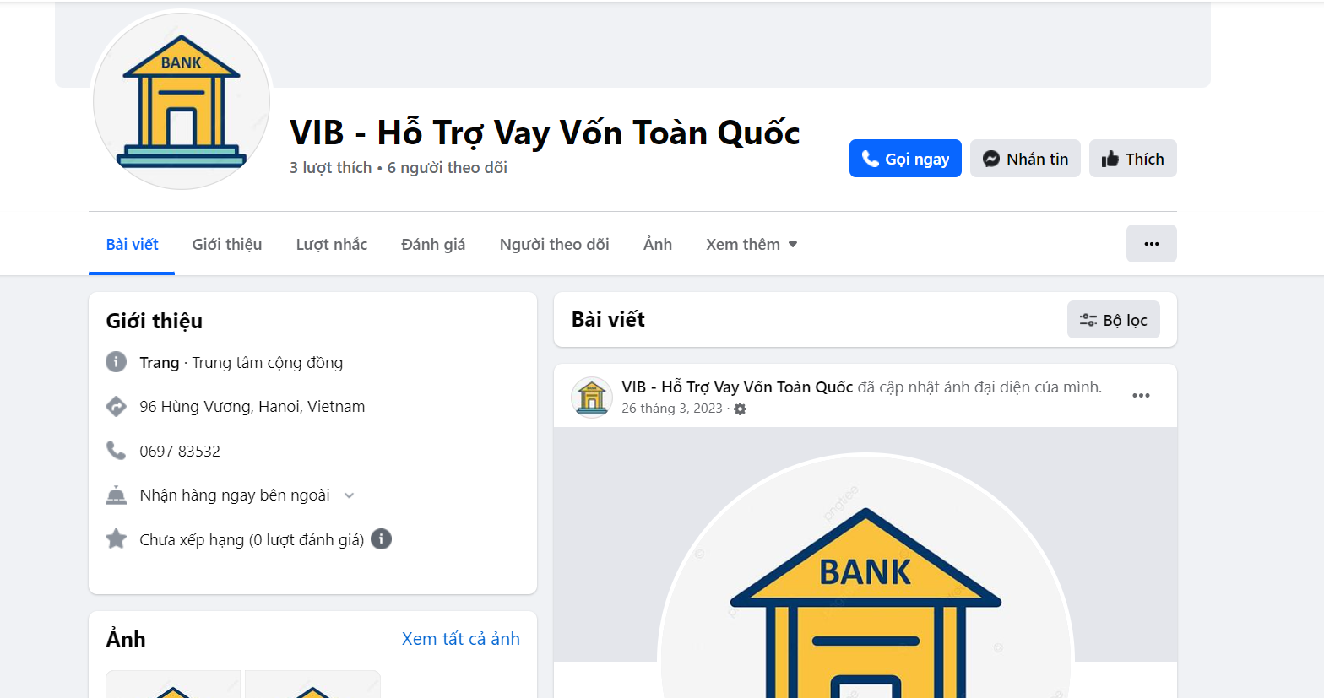

1. <https://web.facebook.com/profile.php?id=100091488615256>

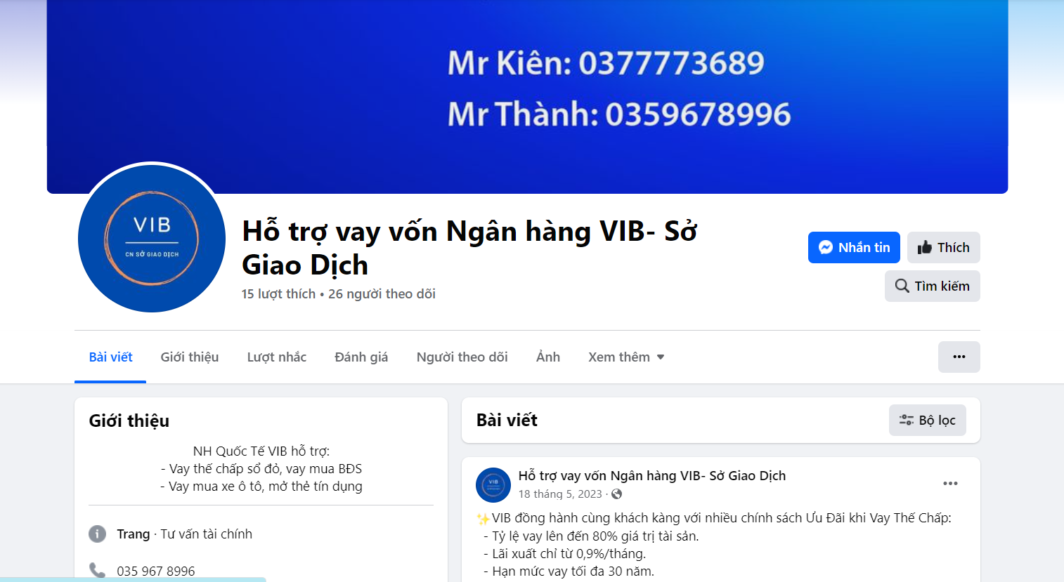

1. <https://web.facebook.com/profile.php?id=100091126916749>

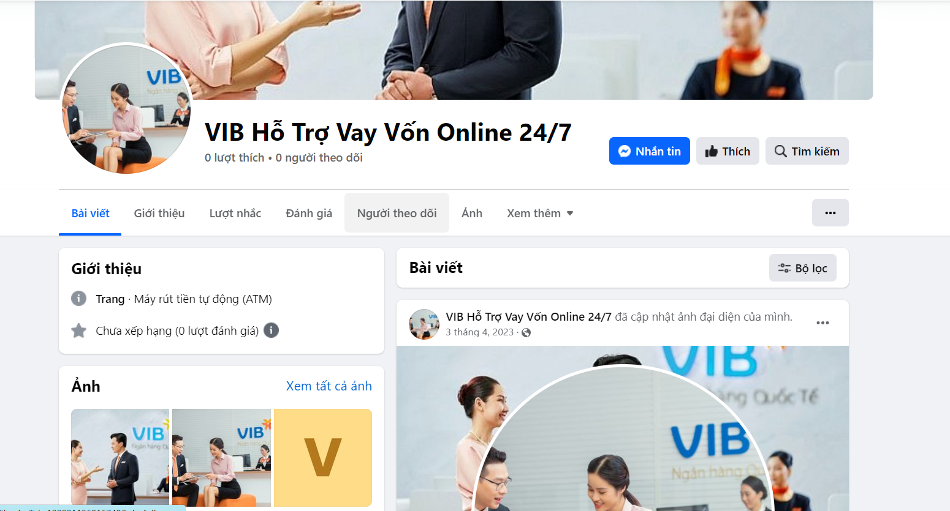

1. <https://web.facebook.com/profile.php?id=100064466778434>

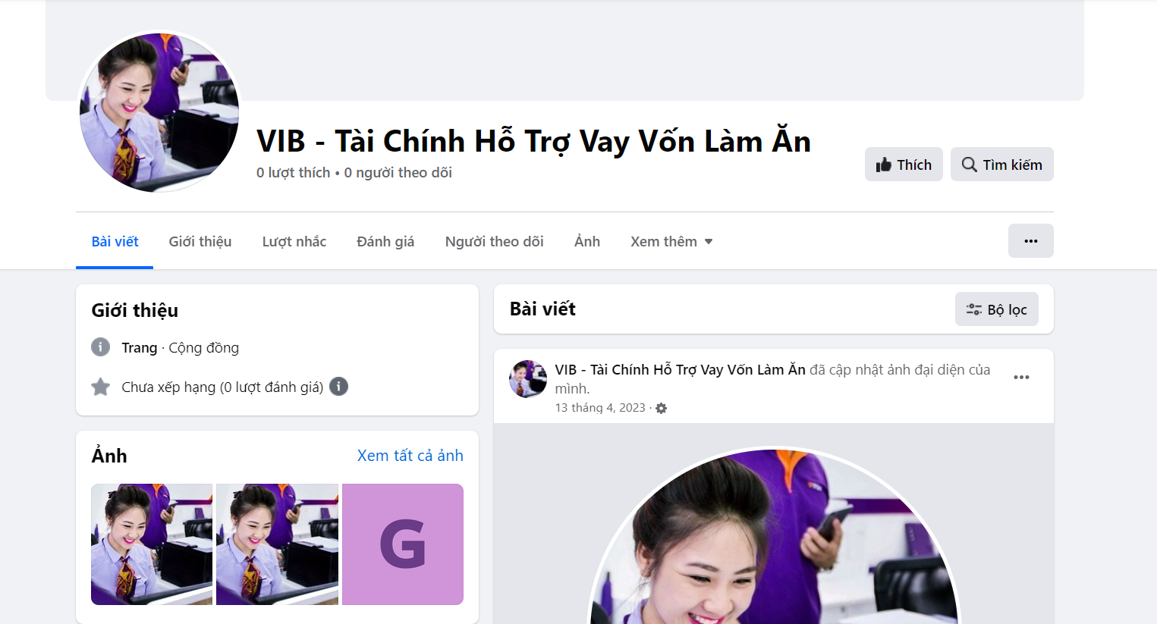

1. <https://web.facebook.com/profile.php?id=100081864126708>

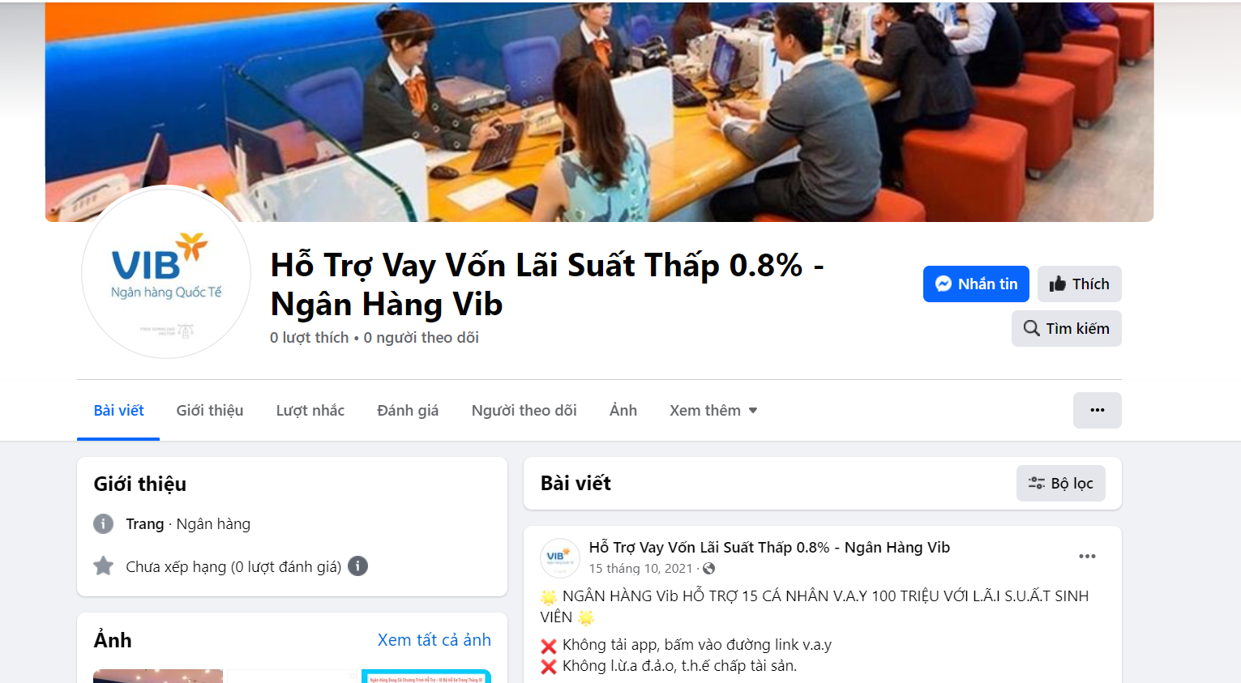

1. <https://web.facebook.com/profile.php?id=100081875335802>

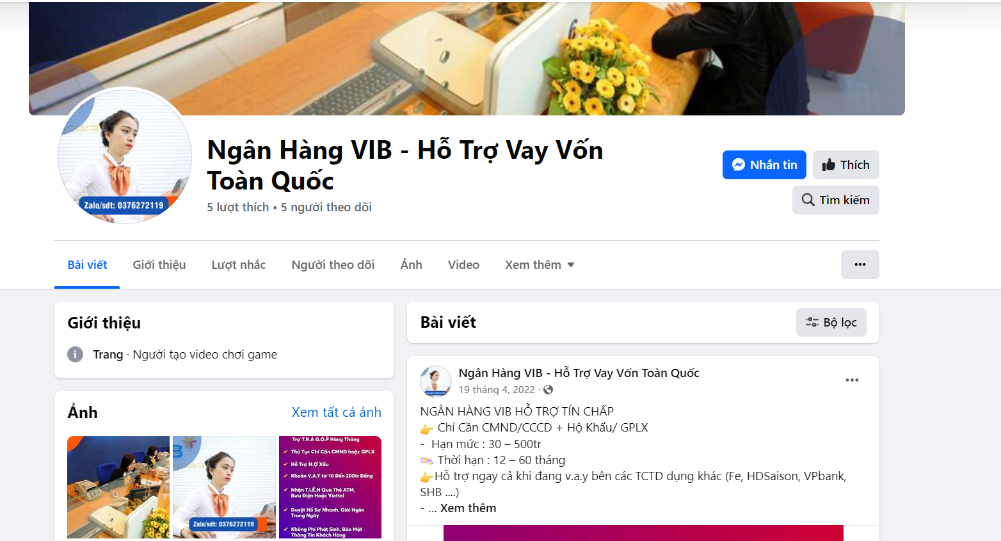

1. <https://web.facebook.com/pages/VIB-S%C3%A0i-G%C3%B2n/178048085696127>

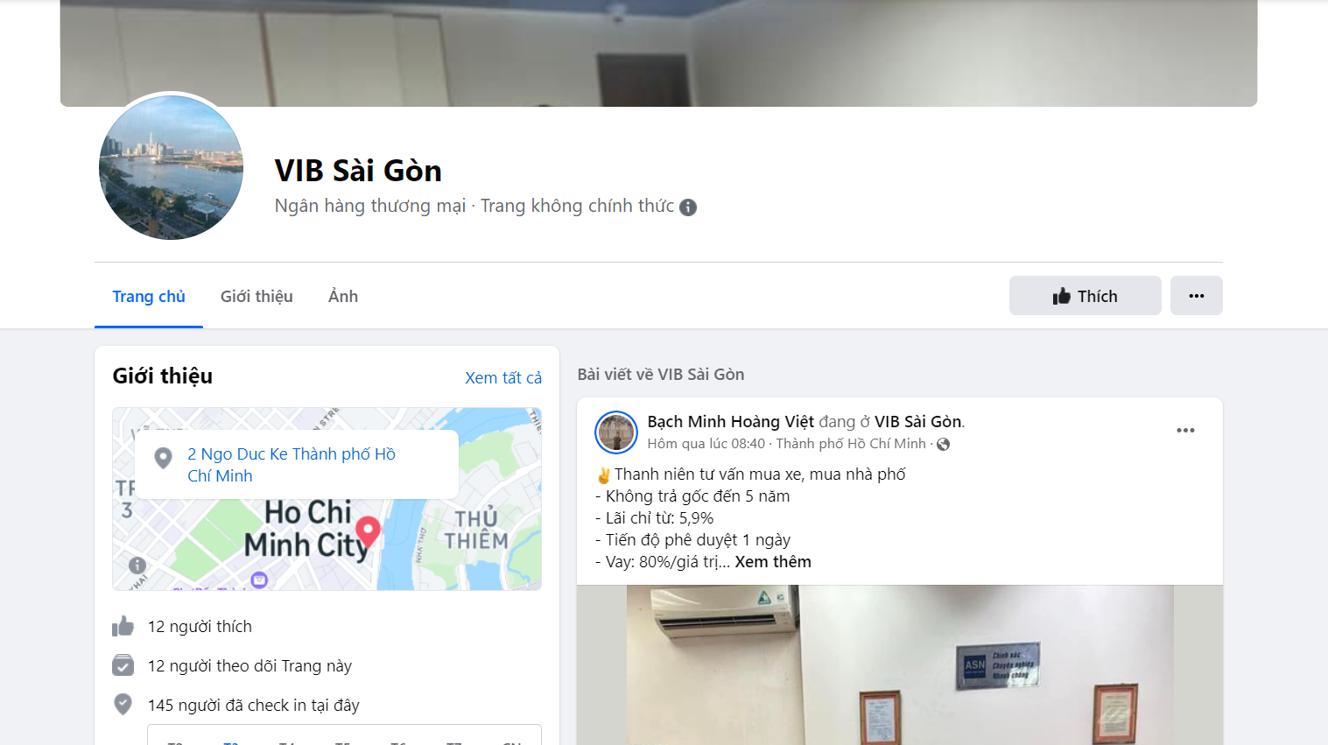

1. <https://web.facebook.com/pages/Vib-Bank/270791409633865>

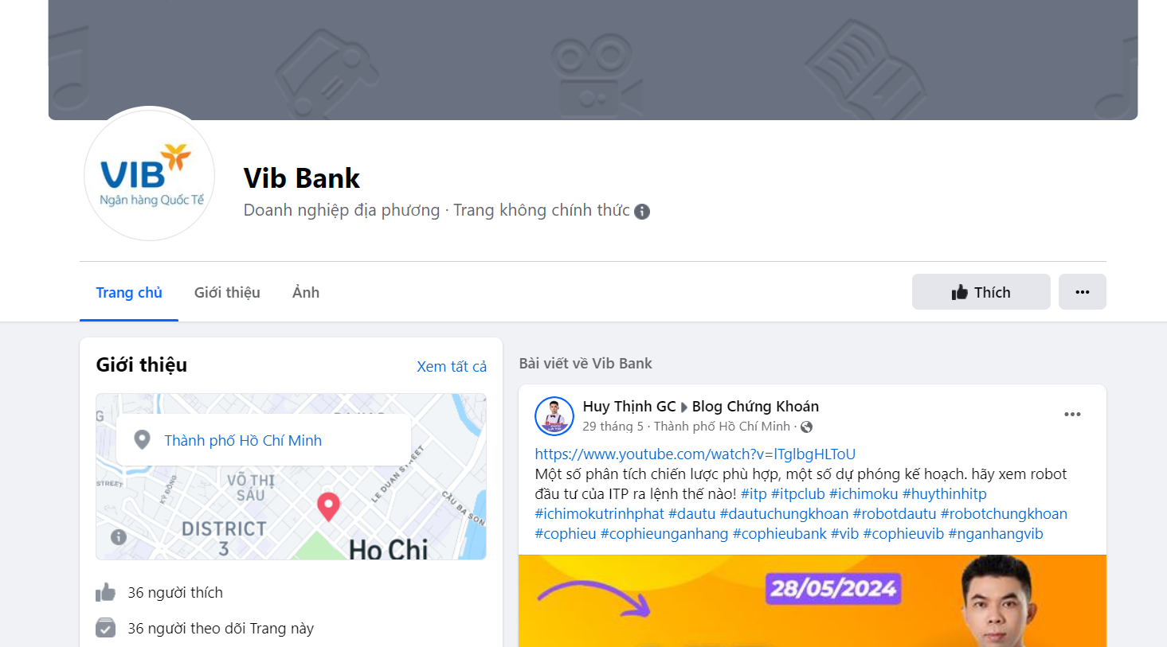

1. <https://web.facebook.com/profile.php?id=61559774348409>

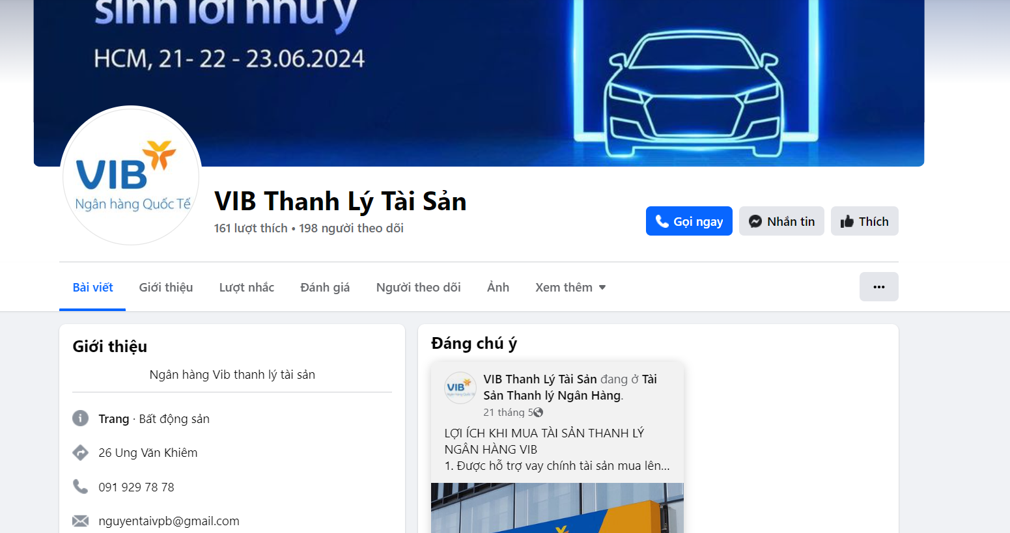

1. <https://web.facebook.com/luckyman.hcm>

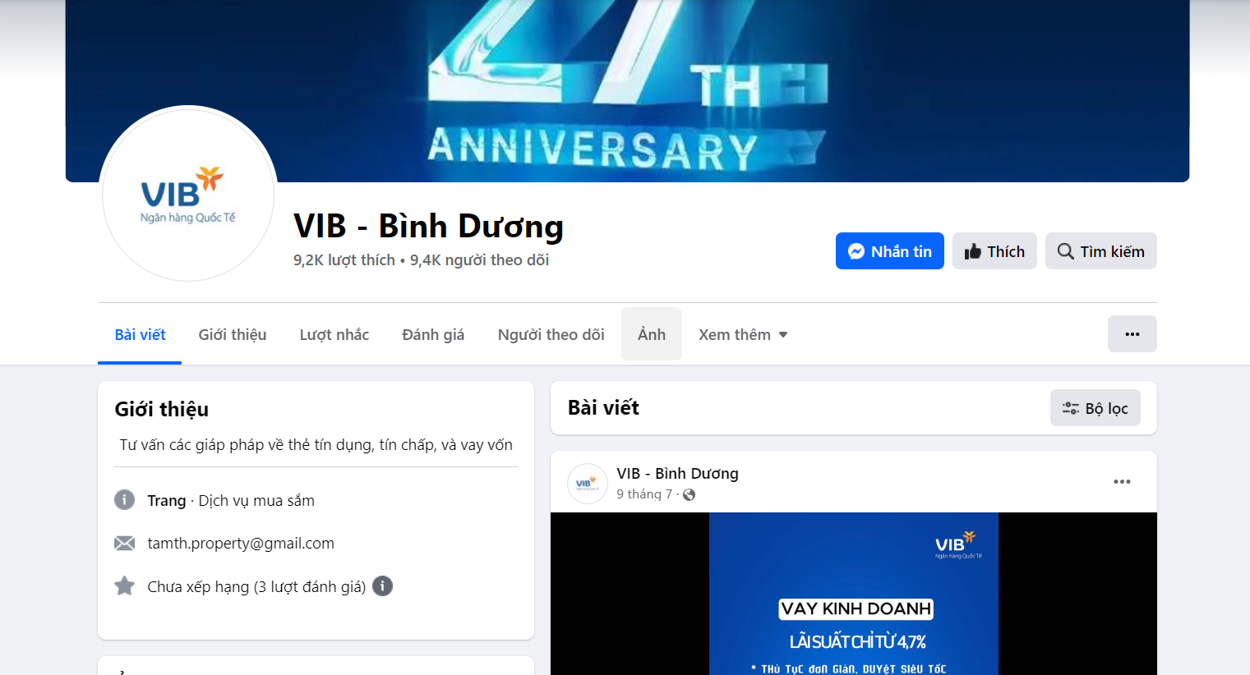

1. <https://web.facebook.com/profile.php?id=61564868095338>

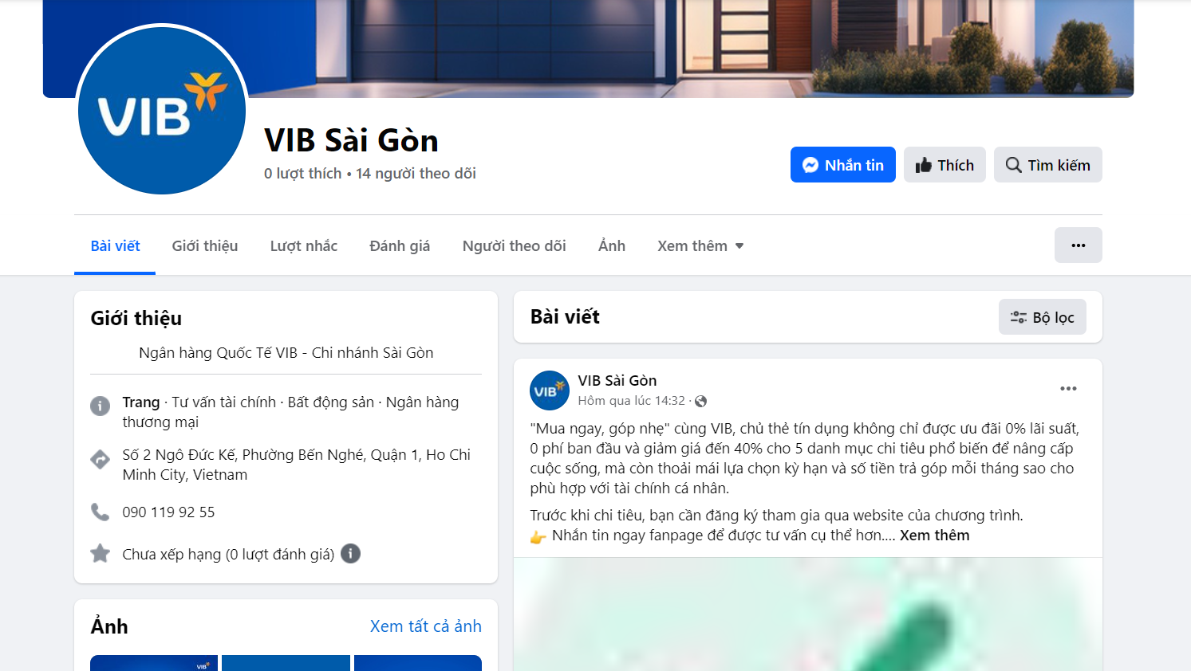

1. <https://web.facebook.com/vibcantho65>

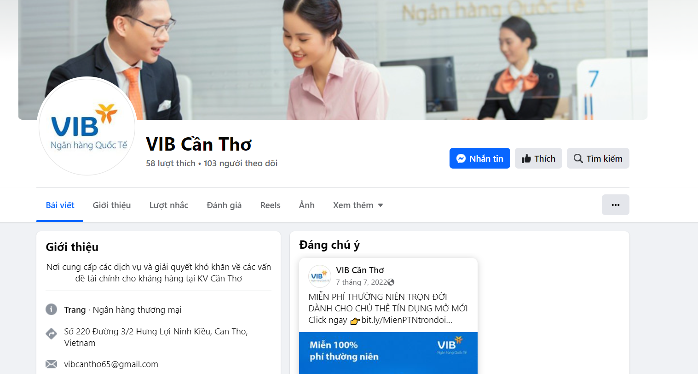

1. <https://web.facebook.com/pages/VIB-H%E1%BB%99i-S%E1%BB%9F-TP-HCM/140594599779120>

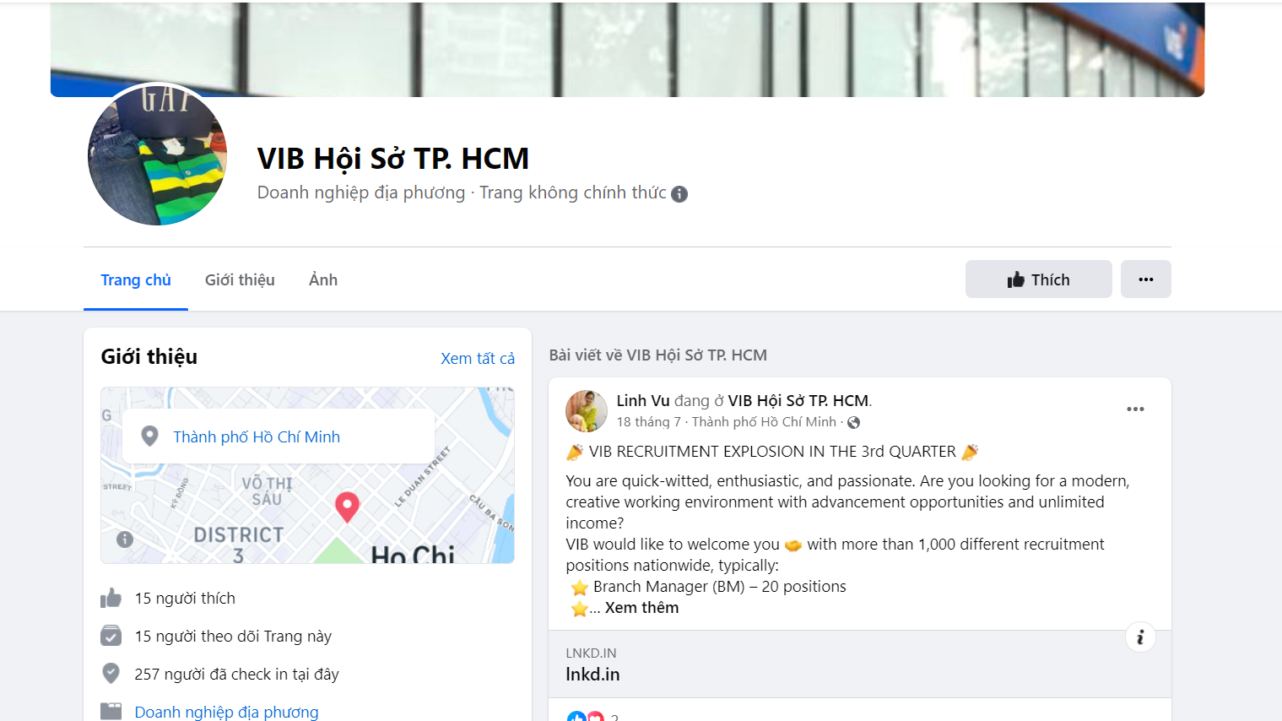

1. <https://web.facebook.com/profile.php?id=61554713669472>

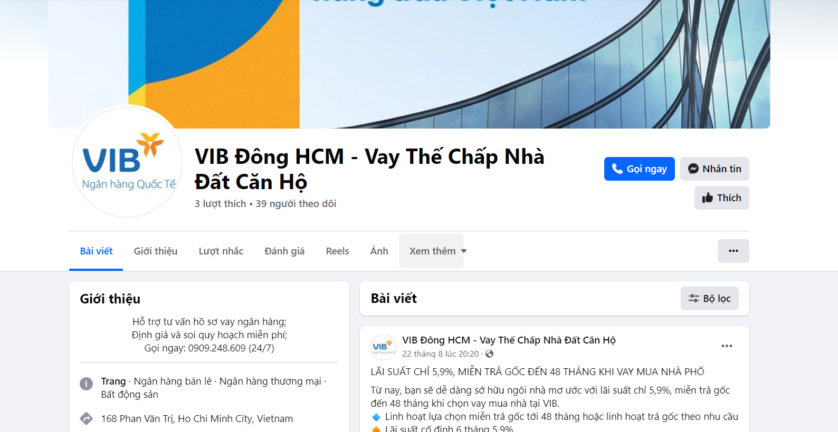

1. <https://web.facebook.com/pages/Ng%C3%A2n-H%C3%A0ng-Qu%E1%BB%91c-T%E1%BA%BF-VIB/456535381064158>

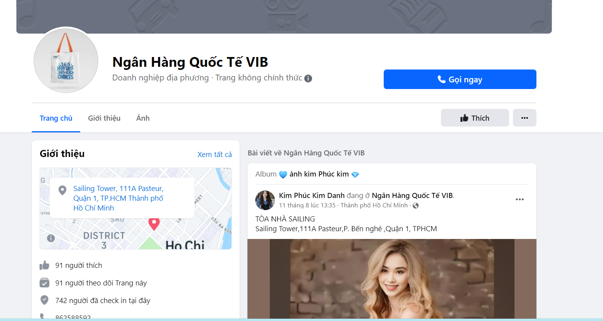

1. <https://web.facebook.com/pages/Vib-Qu%E1%BA%ADn-1/1575871722707888>

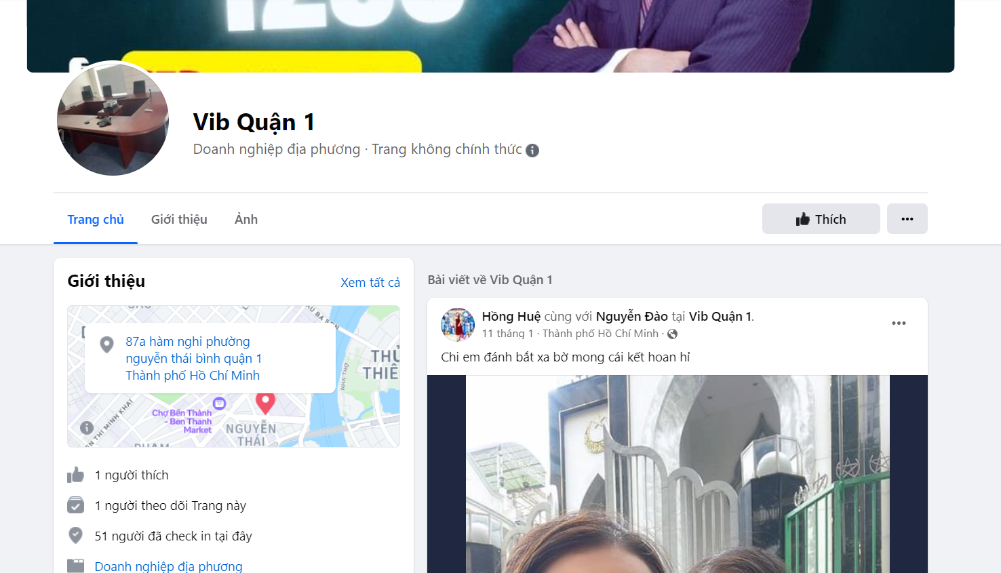

1. <https://web.facebook.com/pages/Vib-Cmt8/1374687525981828>

